ENDNOTE BASIC: The Basics

- Patrons need to create an account for themselves.
From the list of Research Databases on the homepage go to “E” and scroll down to “EndNote Basic” (Must register from a U of Utah IP address the first time.)

- From USearch: conduct search-> select item-> Send to EndNote Basic

- From Ebsco: conduct search->add to folder->open folder
Select all->
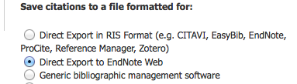

- From Web of Science: conduct search->select items
->save to EndNote online (EndNote online is the same as EndNote Basic and EndNote Web)

- From Google Scholar: select “settings”

Go to Bibliography manager: “Show links to import citations into Endnote”

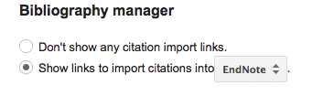

Select “Import into Endnote”

Save the file called “Scholar.enw”

Open EndNote Basic. Go to Collect-> select Import References

Browse for the file Scholar.enw->Endnote Import->select file (“unfiled” or “named by patron”

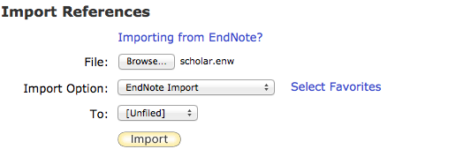

- Scopus
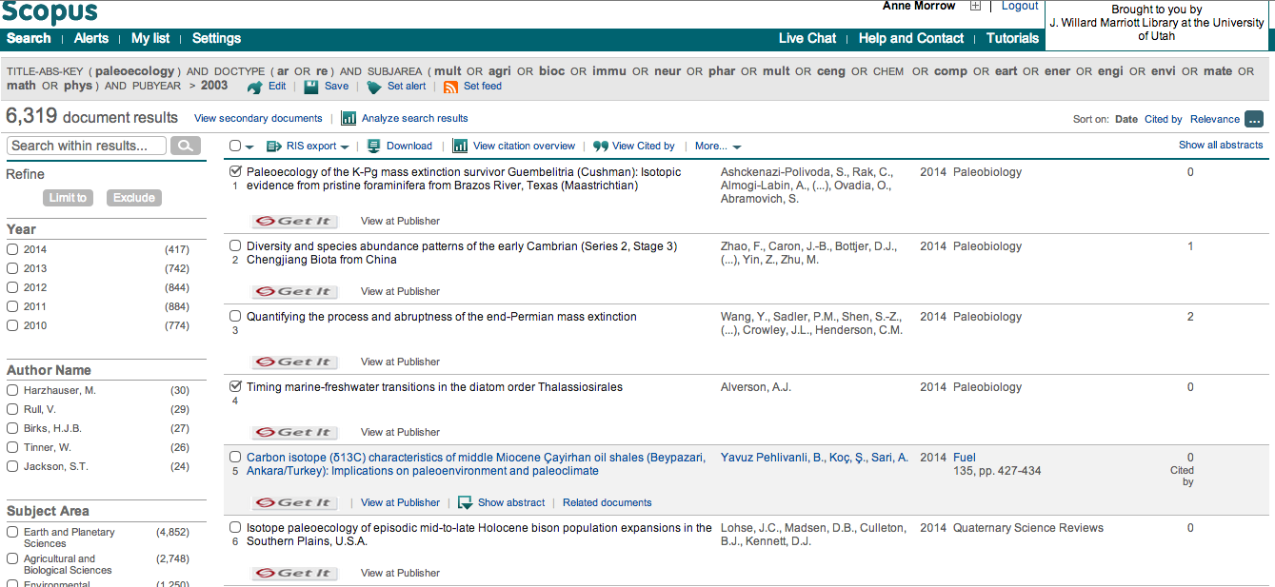

- Create Bibliography: go to Format->Select the group under “references”->select bibliographic style (APA, MLA, etc.)-> “save, email or preview and print” -> allow pop-ups!

Here are the results for “Preview & Print”

